GAYATRI VIDYA PARISHAD
COLLEGE FOR DEGREE AND PG COURSES (Autonomous)
(Affiliated to Andhra University)
VISAKHAPATNAM
Seminar
on
Haptic Technology

Submitted
for the award of the degree of

Master of Computer Applications

By

Kandregula Manoj Krishna
PG222302032

Under the guidance of

Mr. A.V.Prabhakar
Assistant Professor
Department of Computer Applications



Department of Computer APPLICATIONS
gAYATRI vIDYA pARISHAD cOLLEGE FOR DEGREE AND pg cOURSES
RUSHIKONDA, VISAKHAPATNAM-530 045, INDIA
April , 2024

GAYATRI VIDYA PARISHAD
COLLEGE FOR DEGREE AND PG COURSES (Autonomous)
(Affiliated to Andhra University)
VISAKHAPATNAM

Department of Computer Applications

Certificate

This is to certify that the seminar report titled “Haptic Technology” is the bonafide record of seminar work carried out by Mr. Kandregula ManojKrishna (Regd. No. PG222302032), a student of this college, during the academic year 2023-24, in partial fulfillment of the requirements for the award of the degree of Master of Computer Applications.

Signature of the student  Name: K.ManojKrishna  Regd.No.: PG222302032  Course: M.C.A 4th Sem |  | Project Guide  Mr.A.V.Prabhakar  Assistant Professor  Department of Computer Applications
Director of MCA
Prof.I.S.Pallavi

CONTENTS
1. Introduction
1.1 Background and Motivation
1.2 Basic Concepts
1.3 History
2. Related Work
3. Methodology/Technology
4. Features
5.Applications
6. Advantages
7. Disadvantages
8. Conclusions

9. References

1. INTRODUCTION

Haptic technology is a cutting-edge field that focuses on the sense of touch. Unlike traditional user interfaces that rely solely on visual and auditory feedback, haptic technology adds the sense of touch to the interaction.
It enables users to perceive and manipulate virtual or remote objects through tactile sensations. Haptic feedback can range from simple vibrations to complex force simulations, providing a more immersive and intuitive user experience.
Applications of haptic technology span various industries, including gaming, healthcare, automotive, education, and more. By enhancing human-computer interaction with tactile feedback, haptic technology opens up new possibilities for innovation and user engagement.
Haptic technology leverages sensory interfaces to mimic the sense of touch, allowing users to feel textures, shapes, and forces in virtual environments. It facilitates realistic simulations and interactions, enhancing training programs, medical procedures, and design processes by providing users with tactile feedback that closely resembles real-world experiences.
  - Background and Motivation
Haptic technology has emerged as a pivotal element in human-computer interaction, driven by the innate human desire for tactile engagement with the digital world. Traditional interfaces primarily rely on visual and auditory feedback, leaving a gap in the sensory experience.
The motivation behind haptic technology stems from the need to bridge this gap by providing users with tactile feedback, enhancing their immersion and interaction with virtual environments. Moreover, haptics addresses practical challenges in various industries, such as healthcare, gaming, and automotive, where tactile feedback can significantly improve performance, safety, and user satisfaction. Understanding the background and motivation behind haptic technology is crucial for appreciating its transformative potential in modern computing and interaction paradigms.

1.2 Basic Concepts
- Haptic Interfaces: These are the physical or virtual devices that enable users to interact with haptic feedback
- Tactile Sensations: These refer to the various sensations that haptic technology can simulate, including texture, pressure, temperature, and vibration.
- Multimodal Perception: This concept involves integrating haptic feedback with other sensory modalities such as vision and audition to create a more immersive user experience.
- Haptic Rendering: Haptic rendering is the process of computing and generating haptic feedback based on virtual interactions.
- Haptic Interaction Design: It encompasses principles of usability, accessibility, and user experience design specific to haptic interfaces.
- Haptic Communication: This concept includes technologies for remote haptic interaction, enabling users to "feel" and communicate with others over distances.
- Perception and Psychophysics: This includes principles of psychophysics, such as thresholds for detecting tactile stimuli and the perception of force and texture
1.3 History
- Early Developments: Haptic technology traces its roots back to the late 19th century with telegraphy and early attempts at tactile communication. The telegraph's Morse code relied on operators sensing tactile feedback to interpret messages.
- Mid-20th Century Advancements: Significant developments emerged in the mid-20th century, notably with the creation of force-feedback joysticks for flight simulators.These early devices provided rudimentary haptic feedback to users, primarily in industrial and military contexts.
- Emergence of Tactile Feedback: In the 1970s and 1980s, researchers began exploring tactile feedback for human-computer interaction.
Initial experiments focused on simple vibrations and texture simulations.
- Commercialization and Mainstream Adoption: The 1990s saw the commercialization of haptic technology in consumer products, particularly in gaming consoles and mobile devices. Devices like the Nintendo 64's Rumble Pak and early mobile phones with vibrating alerts introduced haptic feedback to a broader audience.
- Expansion into Various Fields: Over the past two decades, haptic technology has expanded into diverse fields, including virtual reality, medical simulation, automotive interfaces, and more.
Advances in hardware and software have enabled increasingly sophisticated haptic experiences, revolutionizing user interaction in numerous domains.
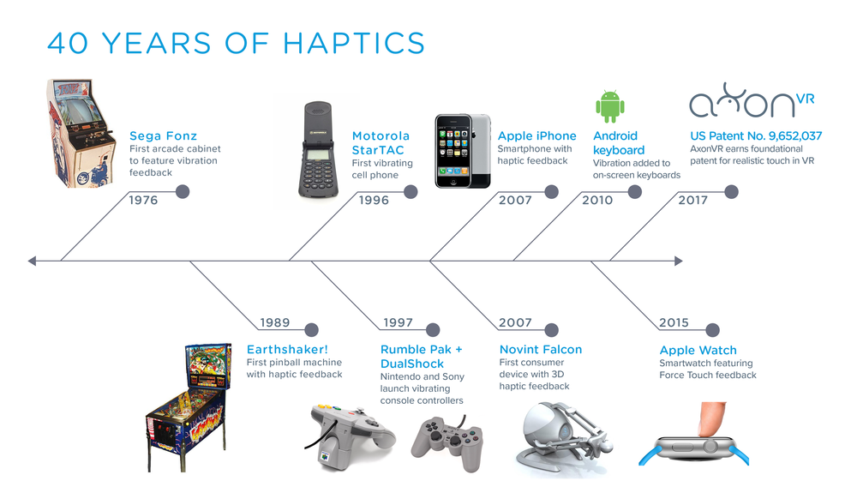
Fig.1 Timeline of Haptic Technology

2. RELATED WORK

Haptic technology finds application across various domains, including engineering and robotics, where it enables the development of tactile feedback systems for remote operations.
In virtual and augmented reality, haptics enhance immersion by providing users with tactile sensations in virtual environments. In medicine and healthcare, haptic technology is utilized in surgical training simulators, rehabilitation devices, and telemedicine systems to provide tactile feedback to users.
In gaming and entertainment, haptic feedback enhances user experiences by providing tactile sensations in gaming controllers and immersive environments. Additionally, haptic technology plays a significant role in accessibility and assistive technology, aiding individuals with disabilities through tactile interfaces and navigation aids.
Research in psychology and perception focuses on understanding human responses to touch stimuli, informing the design of effective haptic interfaces.
Human-computer interaction research integrates haptic feedback into digital systems to facilitate intuitive interaction, while in art and design, haptic technology inspires creative exploration through the creation of immersive tactile experiences and interactive installations.

3. METHODOLOGY

- Sensory Perception: This knowledge informs the design of haptic interfaces and feedback systems to create realistic and effective user experiences.
- Position Tracking: Researchers have investigated techniques to improve tracking accuracy and reduce latency in haptic interfaces for enhanced user immersion.
- Collision Detection: Various collision detection techniques, such as bounding volume hierarchies and distance fields, have been developed to efficiently detect collisions and provide realistic haptic feedback during interactions.
- Haptic Rendering: Haptic rendering involves computing and generating realistic haptic feedback based on virtual interactions.
- Force Calculation: These techniques compute forces based on the physical properties of virtual objects and the user's interactions, providing realistic force feedback during haptic interactions.
- Signal Generation: Researchers have explored methods such as waveform synthesis and frequency modulation to generate vibrotactile feedback and other haptic sensations with high fidelity.
- Actuator Response: Haptic actuators are responsible for generating tactile feedback in response to user interactions.
- Vibrotactile: Vibrotactile actuators produce vibrations that simulate tactile sensations such as texture or impact.
- Solenoid: Solenoid actuators generate mechanical forces through electromagnetism, providing precise and controllable haptic feedback.
- Shape Memory Alloys (SMAs): SMAs are smart materials that change shape in response to temperature changes, offering unique actuation capabilities in haptic applications.
- Sensory Feedback Loop: The sensory feedback loop plays a critical role in haptic interactions, enabling users to perceive and respond to tactile sensations in real-time.
- Force Feedback (Force Reflecting): Force feedback techniques apply resistive forces to the user's interactions, simulating physical constraints and interactions with virtual objects.
- Tactile Feedback: Tactile feedback mechanisms produce tactile sensations such as textures or vibrations to convey information or cues to the user.
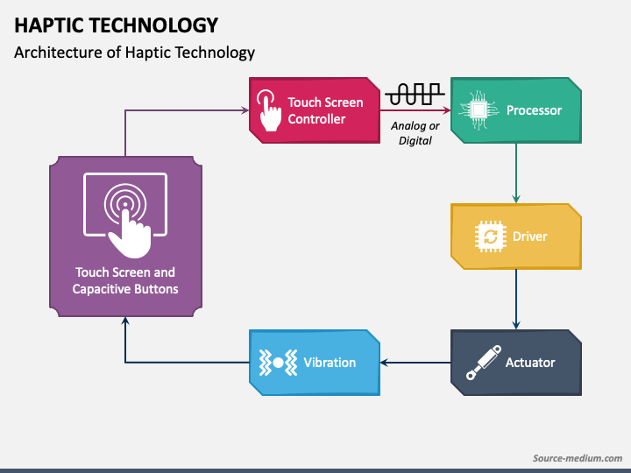
Fig.2 Architecture of Haptic Technology

4. FEATURES

- Enhanced User Experience: Enhances user immersion and interaction by providing physical feedback that complements visual and auditory cues.
- Gesture Recognition: Allows users to interact with devices through gestures, with haptic feedback confirming successful interactions.
- Virtual Sensations: Simulates physical sensations, such as texture, shape, or resistance, to create a more realistic experience in virtual environments or simulations.
- Wearable Integration: Incorporated into wearable devices like smartwatches and fitness trackers to provide notifications, alerts, and feedback without requiring visual or auditory attention.
- Automotive Interfaces: Incorporated into vehicle interfaces to provide tactile feedback for navigation, entertainment, and safety systems, reducing driver distraction.
- Accessibility: Improves accessibility for users with visual or auditory impairments by providing alternative sensory feedback for digital interfaces.
- Fine Control: Enables precise control and manipulation in applications such as virtual reality, surgical simulations, and industrial training.
- Remote Communication: Haptic feedback enhances remote communication by conveying a sense of touch over distances, enabling users to feel a sense of presence or interaction during teleconferencing or virtual meetings.
- Training and Simulation: Haptic technology is used in training simulations across various industries to provide realistic tactile feedback for trainees, allowing them to interact with virtual environments or scenarios without the need for physical objects.

5. APPLICATIONS

- Gaming: In video games, haptic feedback enhances immersion by providing tactile sensations corresponding to in-game actions, such as weapon recoil, impacts, or environmental effects.
- Medical Training and Simulation: Haptic technology is used in medical simulations to provide realistic tactile feedback during surgical training, allowing trainees to practice procedures in a controlled environment.
- Automotive Industry: In vehicles, haptic feedback enhances driver safety and comfort by providing tactile alerts for navigation, collision warnings, and vehicle control systems.
- Industrial Applications: Haptic technology is used in industrial training simulations to provide workers with tactile feedback for tasks requiring fine motor skills or delicate manipulation.
- Teleoperation and Remote Control: In remote control systems, haptic feedback allows operators to feel forces and sensations from a distant environment, improving control and situational awareness.
- Entertainment and Multimedia: Haptic feedback enhances multimedia experiences by providing tactile feedback for movies, music, and virtual tours, adding an additional layer of immersion.
- Consumer Electronics: Haptic feedback is integrated into smartphones, tablets, and other consumer electronics devices to provide tactile feedback for touchscreens, button presses, and gestures, improving user experience and responsiveness.
- Architectural and Engineering Design: Architects and engineers use haptic interfaces to manipulate digital models of buildings and structures, allowing them to feel the spatial relationships and physical properties of their designs. This facilitates more intuitive and immersive design processes.

6. ADVANTAGES

- Improved Interaction: Haptic feedback allows users to interact with digital interfaces more intuitively and efficiently, as they receive tactile confirmation of their actions.
- Multi-Sensory Engagement: By engaging the sense of touch in addition to sight and sound, haptic technology creates a richer and more holistic sensory experience.
- Increased Safety: In applications like automotive interfaces and medical simulations, haptic feedback can provide timely alerts and warnings, enhancing safety by reducing the need for visual or auditory attention.
- Reduced Cognitive Load: Haptic feedback can reduce cognitive load by providing users with immediate and tangible feedback, helping them make decisions and perform tasks more efficiently.
- Realistic Simulation: In virtual environments and simulations, haptic feedback adds realism by simulating physical interactions with virtual objects, enhancing the sense of presence and immersion.
- Therapeutic Benefits: Haptic technology is used in rehabilitation devices and therapeutic applications to provide sensory stimulation and aid in motor skill development or recovery.
- Innovative Interfaces: Haptic technology enables the development of innovative interfaces and interactions that go beyond traditional touchscreens and input devices, opening up new possibilities for design and interaction.
- Reduction of Cognitive Load: By providing physical feedback, haptic technology can reduce cognitive load by offloading information processing from visual or auditory channels, leading to more efficient multitasking and decision-making.
- Creative Expression: In gaming and creative applications, haptic technology can be used to add another layer of expression, allowing developers and artists to create more immersive experiences through tactile sensations.

7. DISADVANTAGES

- Complexity: Integrating haptic feedback into devices or interfaces adds complexity to the design and manufacturing process, which can increase development time and costs.
- Power Consumption: Haptic feedback mechanisms, such as vibration motors, can consume additional power, reducing battery life in portable devices like smartphones or wearables.
- Mechanical Wear and Tear: Components used for haptic feedback, such as vibration motors, may experience wear and tear over time, leading to decreased reliability and performance.
- Limited Realism: While haptic feedback can enhance user experiences, it may not always accurately replicate the feel of physical interactions, leading to a less realistic experience in some cases.
- Maintenance Requirements: Devices with haptic feedback mechanisms may require maintenance or repair over time, adding to the overall cost of ownership.
- Interference with Other Sensors: In some cases, haptic feedback may interfere with the operation of other sensors or components in a device, leading to performance issues or unintended consequences.
- Limited Application Scope: While haptic technology has diverse applications, it may not be suitable for all use cases or industries, limiting its potential reach and impact.
- Size and weight: Haptic actuators and components can add bulk and weight to devices, which may not be desirable in products where slim and lightweight designs are priorities.
- Sensory overload: In some cases, excessive or poorly implemented haptic feedback can overwhelm users and detract from the user experience rather than enhancing it.

8. CONCLUSION

Haptic technology has the potential to revolutionize how we interact with digital content and the physical world, offering new dimensions of sensory experiences. As haptic technology becomes more widespread and accessible, it is essential to consider usability, accessibility, and ethical implications to ensure inclusive and responsible deployment.
The journey of haptic technology is just beginning, and the possibilities for innovation and creativity are limitless. Embracing this technology opens doors to exciting new opportunities for human-computer interaction and beyond.This concise conclusion slide provides a wrap-up of the key points discussed in the presentation, offers insights into the future of haptic technology, and leaves the audience with final thoughts to ponder.

9. REFERENCES

- https://www.d-box.com/how-d-box-uses-haptic-technology/-information/feedback
- https://www.swindonsilicon.com/haptic-technology-making-the-hmi-experience-/m
- https://www.imperial.ac.uk/engagement-and-simulation-science/our-work/research themes/haptic-technology/

